Jesus and Mary’s Senior School -Year 9-

PLAN DE CONTINUIDAD PEDAGOGICA

Week 4

Hi everybody,
We hope you’re okey and missing us a little .
In this new set you will have to work with the book Gold B2 Firt and Ghost Stories. This task must be sent via mail by 13/04/20 in different files (one for the Speaking, one for Reading and one for Literature).
The following tasks will be sent via Google Classroom so please take a look at the invitation and instructions and sign up to your classes.
We are here for you if you have any doubts!
With love,
Lourdes & Mariana

Speaking
Content and Grammar words
- Content words are full of meaning, and they form the core of the communicative message of the sentence. Normally, they include nouns, pronouns, adjectives, verbs, and adverbs.
- Grammar (or Function) words are not so important to the general meaning of the sentence although they essential to its grammaticality. They partly include prepositions, conjunctions, and articles.

GOLD B2 FIRST – COURSEBOOK:
- Unit 1, page 6, Activity 5 (Track N° 1)
- Unit 1, page 7, Activity 6 (Track N° 2)
- Rewrite the sentences in Activity 6, completing
each one so that it is true for you.
- Read the Language Tip on page 7 and answer
the questions in Activity 5 (page 6)
- Go to the Grammar Reference section on
Adverbs of Frequency on page 140. Go
through the explanations and examples. Then,
do Exercise 1.

READING
Cultural note
Coachella is one of the world’s largest and most profitable music festivals, held in Coachella Valley, California. First held in 1999, it is now an annual event which attracts a crowd of around 99,000 people a day.
GOLD B2 FIRST – COURSEBOOK:
- 1) Unit 1, page 8, Activity 1: Answer the questions.
- 2) Read the Cultural Note and answer:
- Have you ever heard about Coachella?
- Find out what happened to Coachella 2020.
- 3) Read the title of the Article and answer: What does
money-making monster mean?
- 4) Read the text for gist (this means to read a text
quickly to understand the main idea without worrying about small details) and find out how the Coachella music festival became so profitable.
- Unit 1, page 8, Activity 2: Read the text again and match phrases 1-7 to paragraphs A-G.
- Unit 1, page 9, Activity 3: Read the first two paragraphs again and answer the questions. Note: Referencing words are used to avoid repeating the same words or phrases again. In a gapped text activity (such as this), referencing words in the text may refer to ideas or things mentioned in the missing sentences, or vice versa.
- Go to Exam Focus on page 187 and read Part 6 carefully.
- Unit 1, page 8, Activity 6. Once you have chosen the best sentence to fit each gap in the text, re-read the article with your answers in the gaps to check it makes sense.
- Unit 1, page 9, Activity 8.
- Unit 1, page 9, Activity 9:
  - Using context to guess the meaning of unknown words is a useful skill in the FCE exam. The important thing is to be able to understand the general idea.
  - Look at the example given and complete the remaining items.

LITERATURE

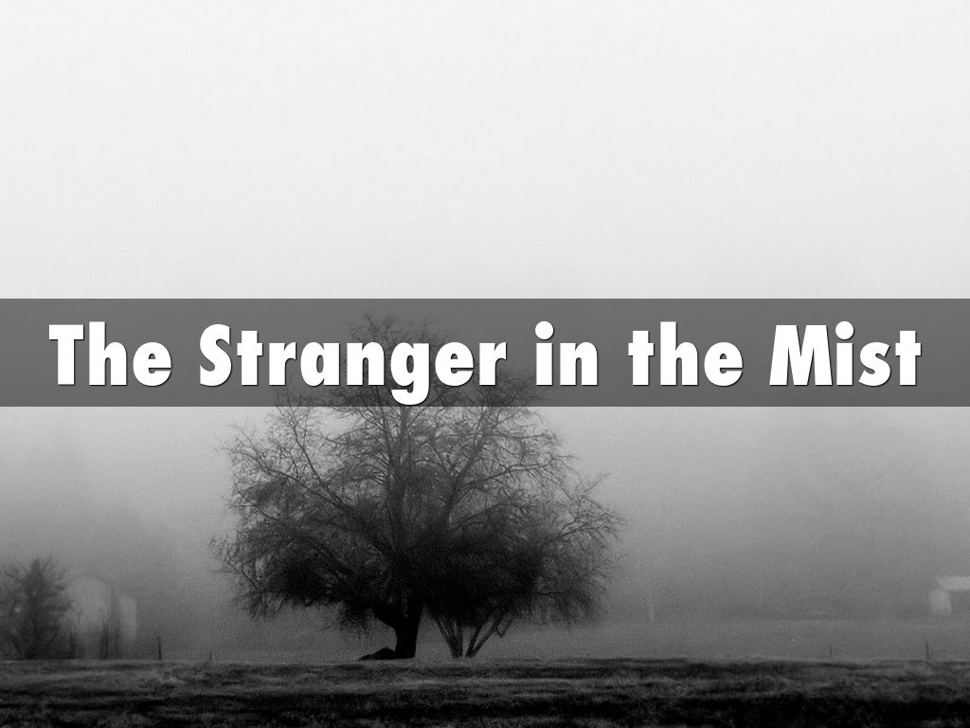

- Complete the ‘While Reading’ Activity on page 92.
- Complete the After Reading Activity (N° 3) on page 95.
- Perhaps this is what one of the characters in the story was thinking:

‘I don’t like this at all. Our guest should have been back hours ago. It’s terrible when it’s misty like this. It’s just like the time a few years ago when that other poor man…I’ll try shouting once again – perhaps he’ll hear me this time…’

- Which character do you think it is?
- What was happening in the story at that moment?
- Choose another character and write a paragraph (similar as the one above) about what he might be thinking at a certain point in the story. Do not forget to clarify who the character is and at what point in the story he was having that thought.

