Hi everybody!
As home school is getting longer than expected from now on, we are going to use Google Classroom for our classes. To be part of your classes you can: i) download the App Google Classroom to your phone/tablet and/or ii) go to classroom.google.com in your computer. If you have a Gmail account, you can find the Classroom among the Google applications as shown below:

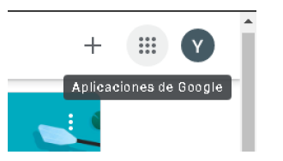

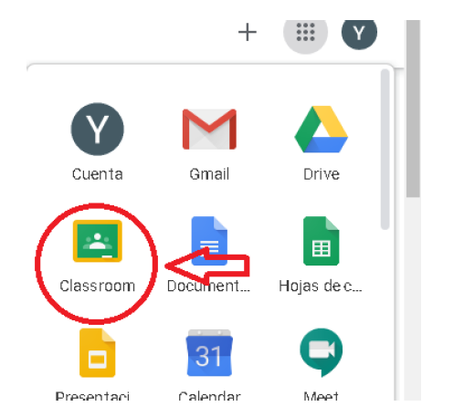

Join a class with a class code
- At the top, click Add Join class
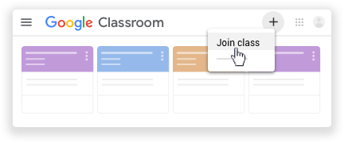
- Enter the class code your teacher gave you and click Join.
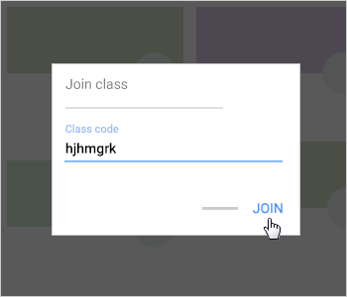

Class Codes:
Use of English Year 9 "A": cd3j6j2
Use of English Year 9 “B”: iafcp6m
Vocabulary Year 9 "A": 4ivoi5n
Vocabulary Year 9 “B”: lzaikho
Reading Comprehension Year 9 "A": tfcldin
Reading Comprehension Year 9 “B”: cfvc2gp

Listening Year 9 “A”: xmnc4qw
Listening Year 9 "B": xcgaabg

Literature Year 9 “A”: 6h3wffn
Literature Year 9 "B": 5j6idnw

Writing Year 9 “A”: cqbo4l6
Writing Year 9 "B": zydvd2h

Speaking Year 9 “A”: wwxbbi2
Speaking Year 9 “B”: cbefgdl

If you have any doubts ask! We are here to help you! Remember that we still have the same email in case you cannot use Google Classroom.

Please join the classes on or before April, 6th and remember that from now on you should check your Google Classes for more activities.
Hope to see you soon!
Lourdes and Mariana

